T3NPlklkhk
Key Skills English

Writing Pupils can:
- identify the audience and purpose for their writing
- select appropriate grammar and vocabulary
- describe settings, character and atmosphere
- use a wide range of devices to build cohesion within and across paragraphs
- ensure the consistent and correct use of tense throughout a piece of writing
- ensure correct subject and verb agreement when using singular and plural, distinguishing between the language of speech and writing

Reading Pupils can:
- check that the book makes sense to them,
- ask questions to improve their understanding
- infer characters’ feelings, thoughts and motives from their actions, and justifying inferences with evidence
- predict what might happen
- summarise the main ideas drawn from more than one paragraph
- discuss and how authors use language, including figurative language, considering the impact on the reader
- distinguish between statements of fact and opinion
- retrieve, record and present information
- participate in discussions about books that are read
- explain and discuss their understanding of what they have read
- provide justifications for their views.

Grammar Pupils can:
- use a range of tenses including past progressive, present progressive, past perfect
- use expanded noun phrases to convey complicated information concisely
- use modal verbs or adverbs to indicate degrees of possibility
- use relative clauses beginning with who, which, where, when, whose, that or with an implied (i.e. omitted) relative pronoun
- use commas, brackets, dashes or commas accurately
- use semi-colons, colons or dashes correctly
- use a colon to introduce a list
- punctuate bullet points consistent

Mathematics Pupils can:
- read, write, order and compare numbers up to 10 000 000
- multiply multi-digit numbers up to 4 digits by a two-digit whole number
- divide numbers up to 4 digits by a two-digit whole number
- solve addition and subtraction multi-step problems in contexts, deciding which operations and methods to use and why
- recall and use equivalences between simple fractions, decimals and percentages
- solve problems involving the calculation of percentages [for example, of measures, and such as 15% of 360]
- solve problems involving the calculation and conversion of units of measure

Endeavour Academy
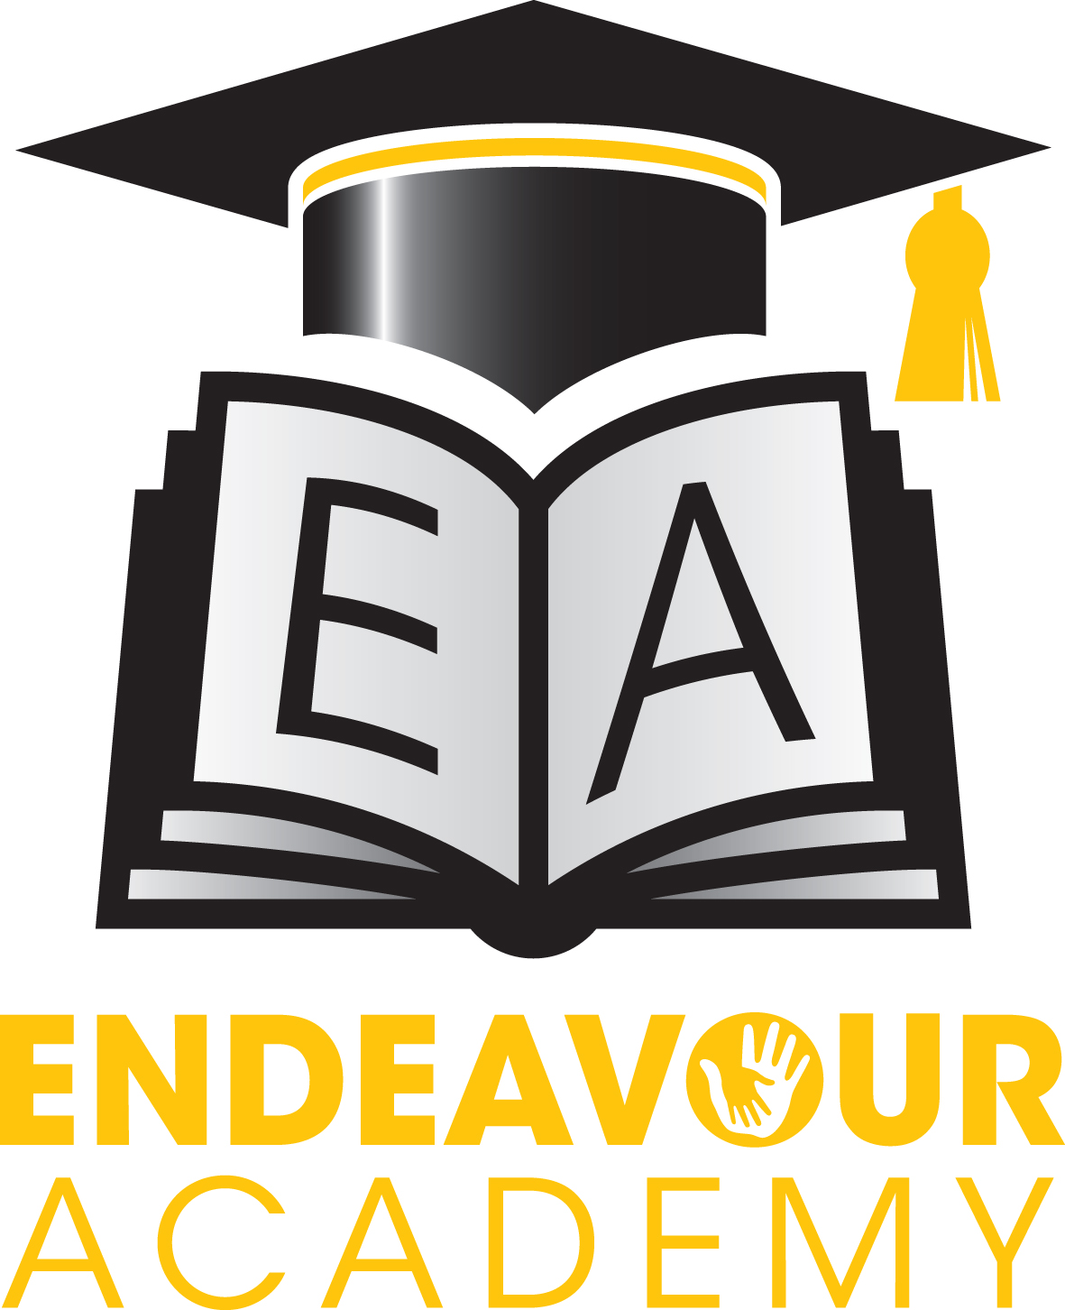

Supporting your child’s learning at home.
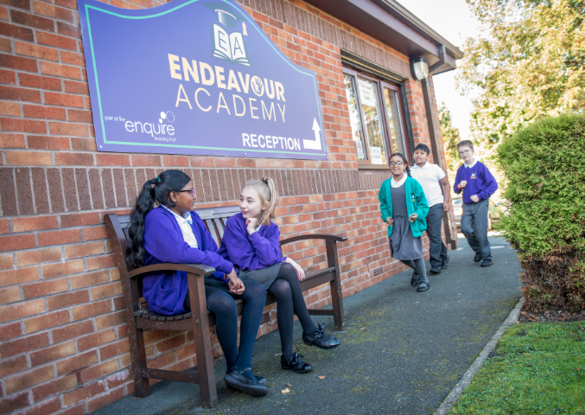

Year 6

``
Recommended Reads!
- Stone Cold by R. Swindells
- Storm Breaker by Anthony Horrowitz
- Noughts and Crosses by Malorie Blackman
- Pig Heart Boy by Malorie Blackman
- Once by M. Gleitzmann
- The Other Side of the Truth by B. Naidoo
- Skellig by D. Almond
- The Lion, the Witch and the Wardrobe by C.S Lewis
- Carrie’s War by Nina Bawden
- The Thief Lord by Cornelia Funke

Apps and Useful Websites
★www.bbc.co.uk/bitesize/ks2 ★www.mathszone.co.uk ★www.topmarks.co.uk ★www.woodlands-junior.kent.sch.uk ★www.coxhoe.durham.sch.uk ★www.horrible-histories.co.uk
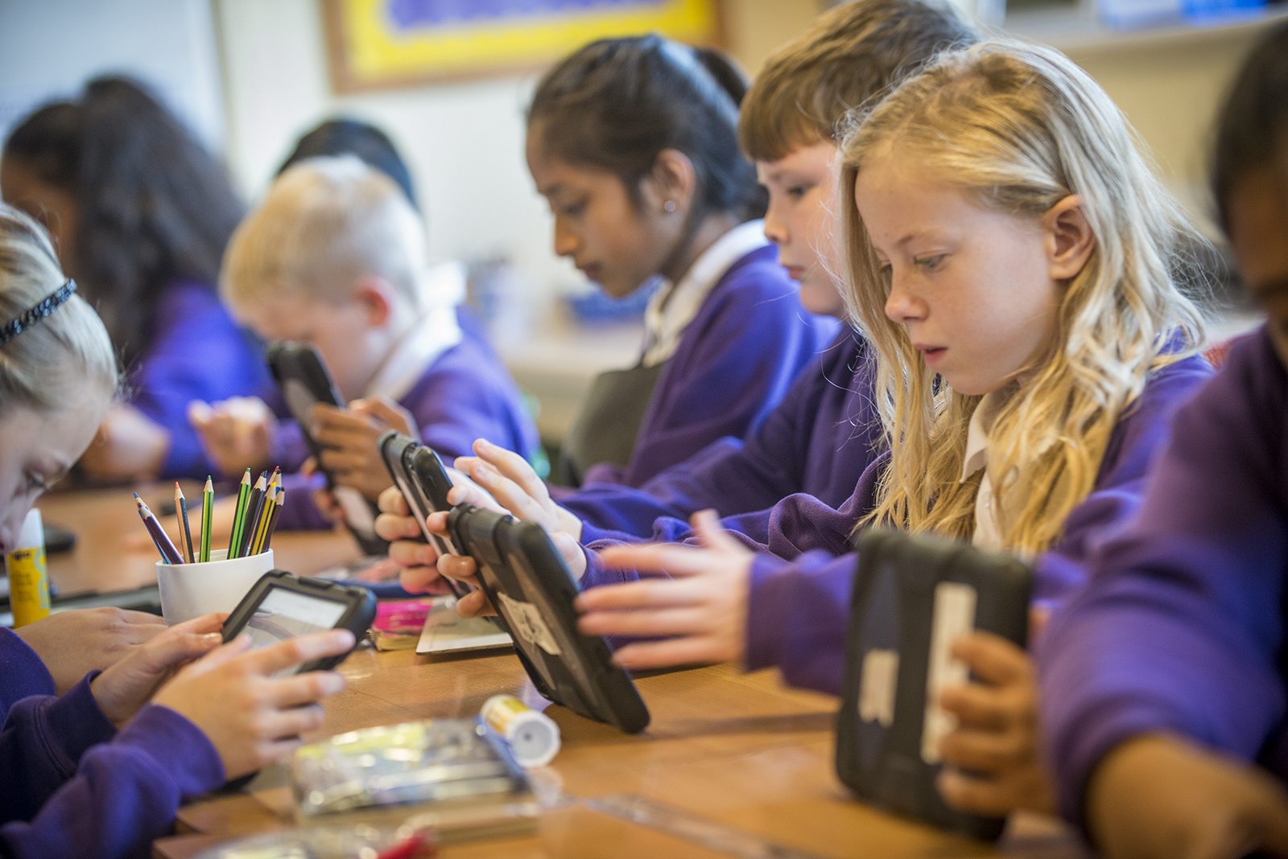
Calculation strategies
Addition Subtraction
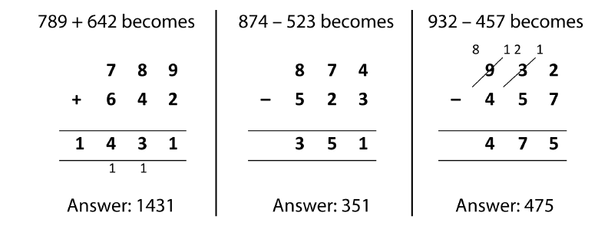
Multiplication
Short Multiplication Long Multiplication

Division
Short Division

Long Division

Learning and reflection

At Endeavour, we encourage children to talk about their learning experiences and to explain their reasoning. You can support your child be discussing their day at home.

Reading
- How did the author make you feel? Why?
- How did the character make you feel about…?
- Who else would/wouldn’t enjoy this book? Why?

Writing
- How do you want the author to feel when writing…? Why? What is the intended impact?
- What does your choice of verbs/adverbs tell the reader about your character?
- As an author, how does your writing interest the reader and make them want to continue reading?

Maths
- Can you explain what is wrong with the example below and correct the error?
- Do you agree with this calculation?
I agree/disagree because…
- How could you prove that…?
To prove that….you need to…
- Is this statement/calculation correct?
The …..is/isn’t correct because…
I can prove this by….
To demonstrate this you can…

General
- Is there anything you have learned that will help you with another learning challenge?
- What were your useful learning mistakes?
- When could you apply your learning to another situation?



